EXPLANATION
This" and "that" are singular (one).
These" and "those" are plural (more than one).
Use "this" and "these" to talk about things that are near in space or in time.
Use "that" and "those" to talk about things that are farther away in space or time.

complete with :

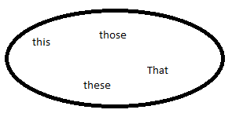

.a)__this___ car is dirty. Este automóvil está sucio.
b)That house is expensive. Aquella casa es costosa.
c)These apples are cheap. Estas manzanas son baratas.
d)These pencils are in the box. Estos lápices están en la caja.
e)Those stars are in the sky. Aquellas estrellas están en el cielo.
f)Those boys are my friends. Aquellos niños son mis amigos.
g)This flower is beautiful. Esta flor es hermosa
h) That dog is bad. Aquel perro es malo.
remember that :
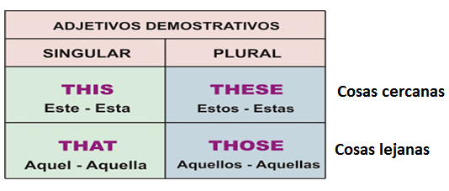
1. Esta casa es demasiado grande. This. house is too big.
2. Estos son mis alumnos. These are my pupils.
3. Esta ventana es pequeña. This window is small.
4. Este es mi libro. This is my book.
5. Estas flores son hermosas. These flowers are beautiful.
6. Estos zapatos son negros. These shoes are black.

7. Este perro es malo. This dog is bad.
8. Estos niños juegan en la calle. These children play in the street.
9. Estas son mis fotos. These are my pictures.
10. Esta mesa es mía. This table is mine.

Write these words in a suitable table.
Neck, clown, singer, arm, cheese, fireman, butter, elbow, pie, vet, sweets, butcher, mouth, fish, tomato, pilot, rice, knee, farmer.

Jobs | Food | Body
Clown | cheese | Neck
Singer | Butter | Arm
Fireman | pie | Elbow
Vet | Sweets | Mouth
Pilot | Fish | Knee
Farmer | Tomato
butcher | Rice
Choose the correct answer.
- This pilots this pilot
- These artists these artist
- Those vets that vets
- That butchers this butcher
- This singers these singers
- This tooth these tooth
- These feet this feet

WRITING PRACTICE
Choose 10 Computer components, paste samples of pictures and write sentences using: this is, that is, these are and those are.
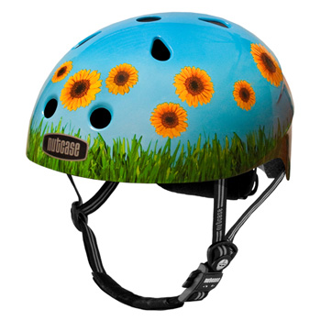
Example:
that is a helmet ---------------------------------------------

This graphic card
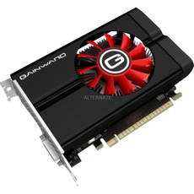
These two speakers------------------------------------------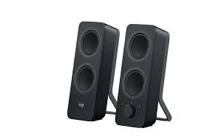

This is a monitor
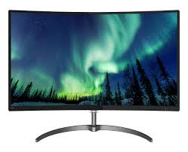
This is a webcam
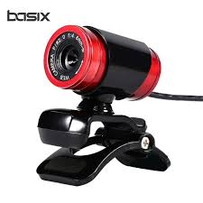
This is a computer tower
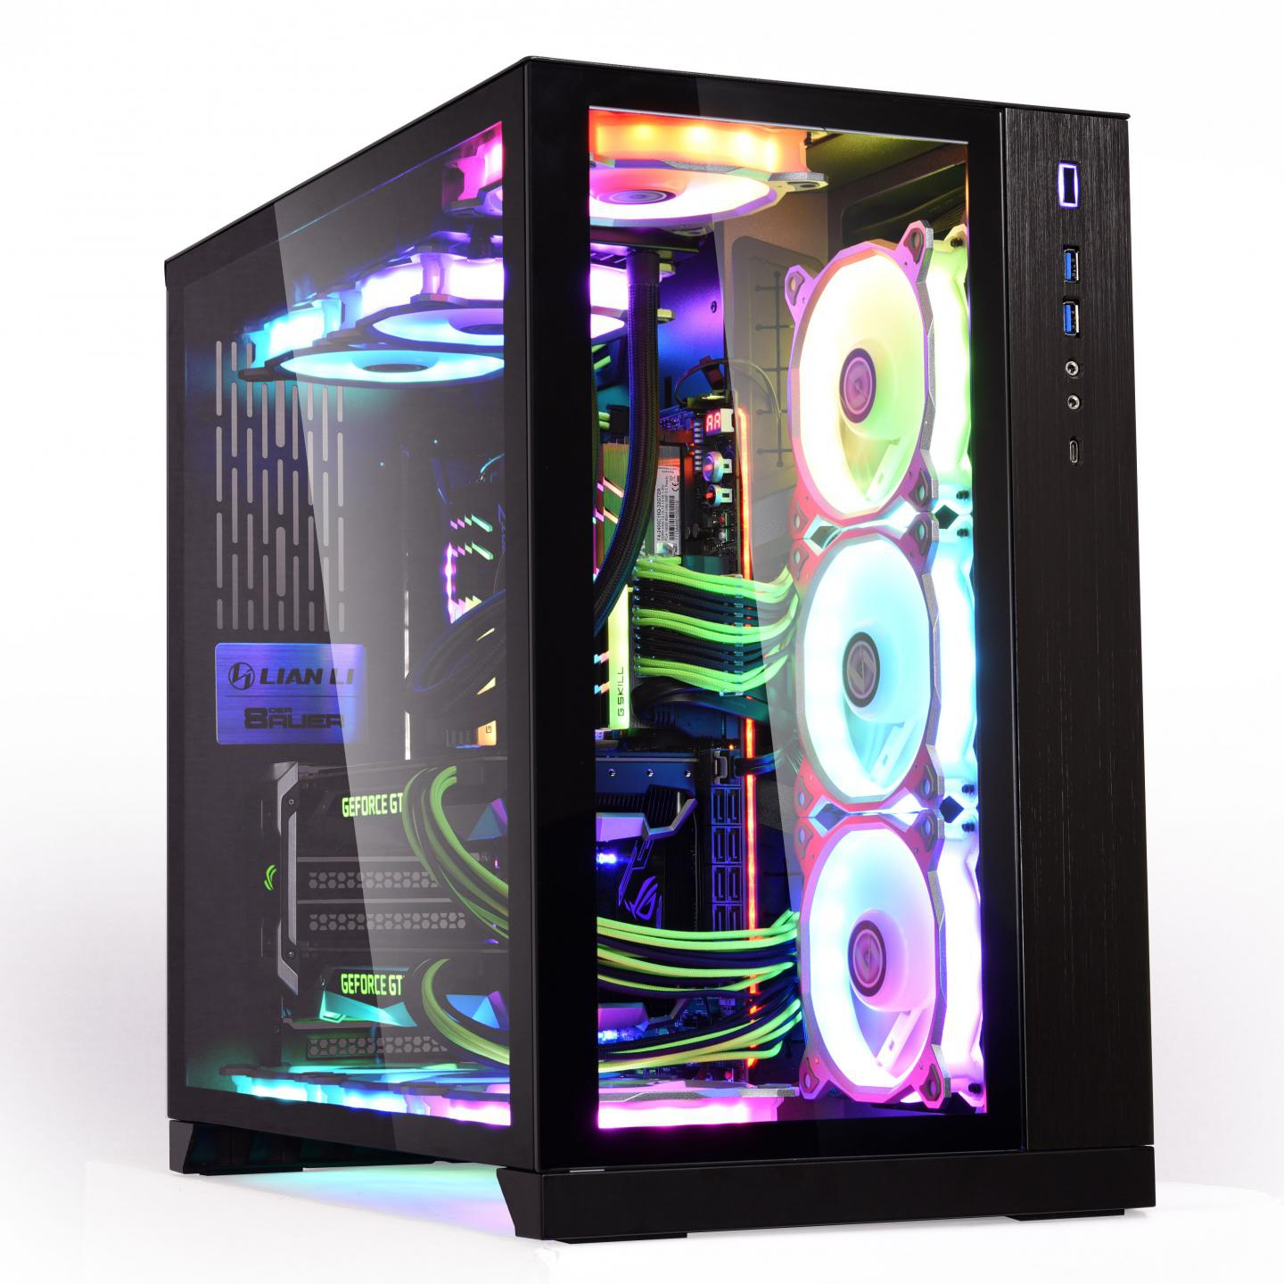

Those are two rams---------------------------------------------
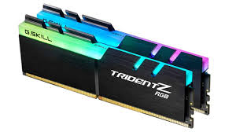
That is mouse--------------------------------------------------------------------
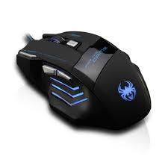
This is a Keyboard
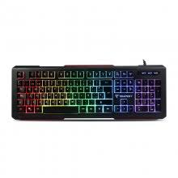

These are two andirons
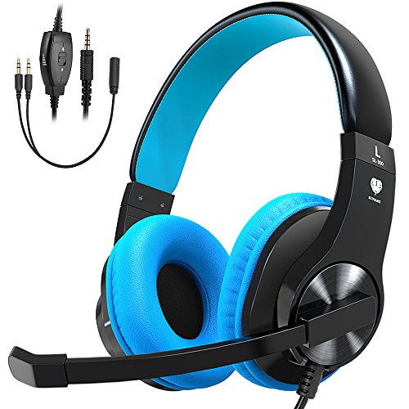
This is a source of power
